

**PARTNERSHIP PROGRAMS OF**

**UNIVERSITY OF INFORMATION TECHNOLOGY, VNU- HCM**

**BIRMINGHAM CITY UNIVERSIRY, ENGLAND**

**Nguyen Tran Gia Huy**

**20520106-KHBC2020**

**Internship Report**

**Ho Chi Minh city, 06/2022**

**National University of Ho Chi Minh City**

**University of Information Technology**

**Faculty of Computer Sciences**

**Internship Report**

**Internship company :** **Minh Phuc Telecom**

**Mentor: Master Le Minh Tien**

**Instructor: Master Nguyen Thanh Tam**

**Student’s name: Nguyen Tran Gia Huy**

**20520106 - KHBC2020**

**Submission Date: 26/06/2022**

**Contents**

**Chapter 1: About the company** 6

*1.* *General information about the company* 6

*2.* *Leadership* 6

*3.* *Field of activity* 6

**Chapter 2: Plans and assigned work** 7

*1.* *Internship position* 7

2. Internship period 7

3. Jobs 7

**Chapter 3: Work content** 8

I. Project 1: Reporting departments monthly by using Power BI. 8

A. Overview of the project: 8

B. The project has to have these basic function: 8

C. Achievement: 8

D. Results of reporting departments monthly 14

II. Project 2: Reporting the Interface status of Switch and Bandwidth Information by using Prometheus and Grafana. 18

A. Introduction: 18

B. Overview of project: 20

C. Achievement: 20

D. The Process to perform the project 20

**Chapter 4: Comments and Experiance after 3-month internship** 27

1. Comments on internship program 27

2. Experience after internship program 27

**ACKNOWLEDGEMENTS**

Dear BOD of Minh Phuc Company and IT Department,

Firstly, I would like to express my special appreciation and thanks to Mr Tien Le (Head of IT Department).

Our 3-month internship at IT Department has come to an end. I would like to thank you for providing me guidance during our internship. I have gained valuable insights into researching over the past 3 months.

I have been given the opportunity to work on 2 projects with different team members and the working experience has been wonderful. Over the past three months, I can do different things and explore different areas from what I are currently majoring in our university.

Your guidance has been inspiring and has provided me a better understanding of knowledge and technical skills. I am really glad that I have chosen IT Department to be the place where we could improve ourselves. Hoping to work at this place again in the near future.

**MENTOR’S COMMENTS**

Ho Chi Minh City, ……. …………

**Mentor Signature**

Chapter 1: About the company

1. ***General information about the company***

Minh Phuc Telecom was established in 2002, MP Telecom is a pioneer in the field of Contact Center in Vietnam. During its development, MP Telecom has always strived to become a leading provider of Contact Center and Business Process Outsourcing (BPO) solutions thanks to the close combination of three main platforms: People – Technology – Solutions law.

Website of Company: [*https://mptelecom.com.vn/*](https://mptelecom.com.vn/)

1. ***Leadership***

Head of IT Department: Mr Le Minh Tien

1. ***Field of activity***

From the understanding of customers, the understanding of the service sector in terms of personnel and technology has motivated MP Telecom to always be active and not afraid to renew themselves according to the development pace of the times.

The repositioning, changing the brand identity to create a different impression, as well as convey the new development direction of the company.

Services of MP Telecom:

* Customer Care
* Tele-Services
* HR Supply & Training
* Technical Support Service
* Data Entry
* SMS & Voice Brandname
* MobileSIP & Simbox
* Technology Solutions

# Chapter 2: Plans and assigned work

1. ***Internship position***

IT Support Intern

1. **Internship period**

* Started on 14/3/2022 and end in 14/6/2022
* Part-time intern

1. **Jobs**

* Assigned for Nguyen Tran Gia Huy:
* Project 1: Reporting departments monthly by using Power BI.
* Project 2: Creating two diagrams which illustrate Port Satus Up or Down and Admin of Banwidth Information of technological devices by using Prometheus and Grafanas dashboard.

Chapter 3: Work content

1. **Project 1: Reporting departments monthly by using Power BI.**
2. **Overview of the project:**

* Creating and separating tables in Excel by using the language: *Python*
* Importing and Exporting database for following requirements by using Diagram Analysis Application: *Power BI*

1. **The project has to have these basic function:**

**+ Excel:** Understanding all valuable information of reporting departments monthly. Besides, using Python to separate tables for analysing explicitly values in each sheet

**+ Power BI:** Importing database from excel to Power BI fields, then using suitable graphs for demonstrating clearly all information values in each diagram.

+ Spent 2 weeks to get the idea, then processing to work.

1. **Achievement:**

- Demonstrating by using a variety of charts in Power BI which is suitable with databases in each table of sheets

- Created an interface with colours, forms and backgrounds that is simple to look.

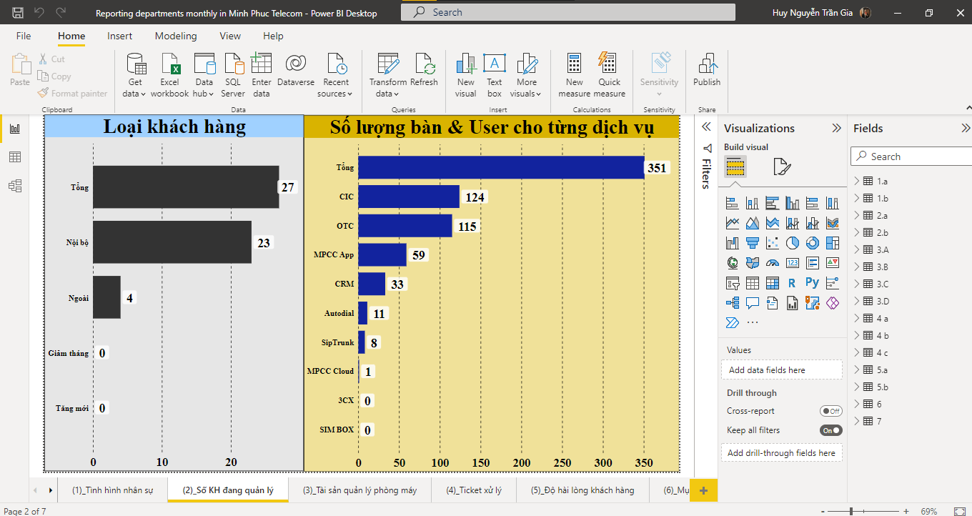

(Image of reporting departments monthly by using charts in Power BI)

**Step 1:** Setting character numbers for each group of department status and device information to manage easily.

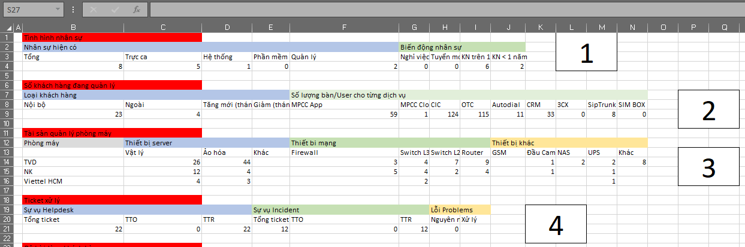

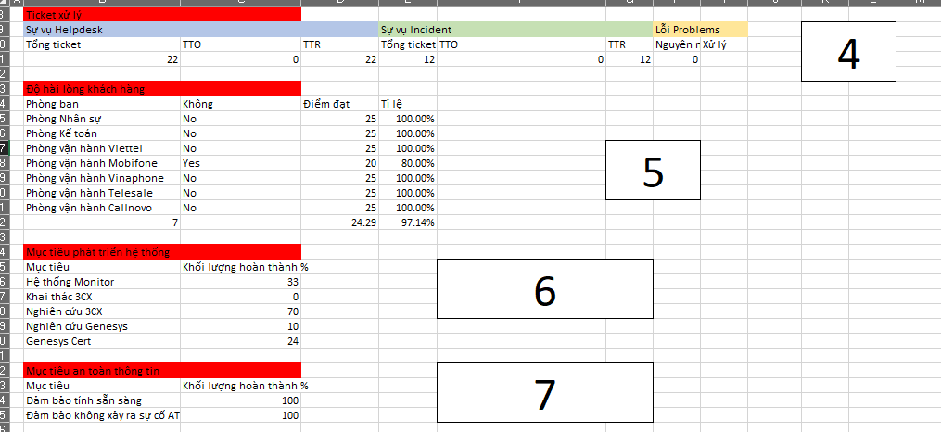

**Step 2:** Using Python for converting valuable information from horizontal to vertical table to create clearly databases before importing to Power BI.

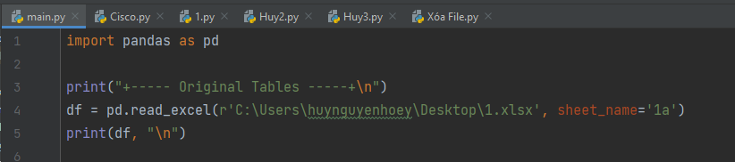

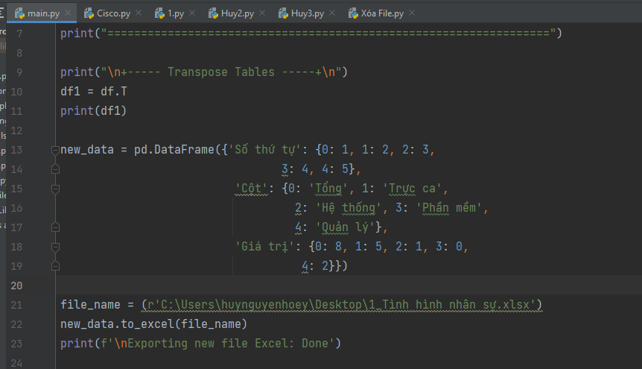

**Source code:**

|  |
| --- |
| import pandas as pd  print("+----- Original Tables -----+\n")  df = pd.read_excel(r'C:\Users\huynguyenhoey\Desktop\1.xlsx', sheet_name='1a')  print(df, "\n")  print("==================================================================")  print("\n+----- Transpose Tables -----+\n")  df1 = df.T  print(df1)  new_data = pd.DataFrame({'Số thứ tự': {0: 1, 1: 2, 2: 3,  3: 4, 4: 5},  'Cột': {0: 'Tổng', 1: 'Trực ca',  2: 'Hệ thống', 3: 'Phần mềm',  4: 'Quản lý'},  'Giá trị': {0: 8, 1: 5, 2: 1, 3: 0,  4: 2}})  file_name = (r'C:\Users\huynguyenhoey\Desktop\1_Tình hình nhân sự.xlsx')  new_data.to_excel(file_name)  print(f'\nExporting new file Excel: Done') |

**Results:**

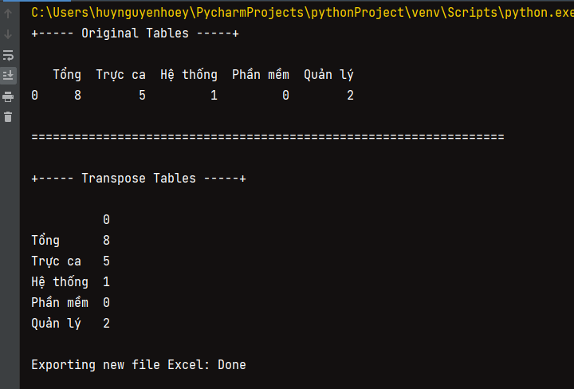

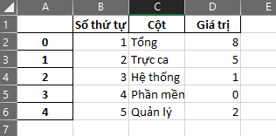Then, open a new file exporting currently and deleting the first columns of index to make valuable information in table more clearly.

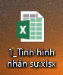

**Step 3:** Extra-task during working on this project by Mr Tien Le (Head of IT Department of MP Telecom)

Using Python to delete temporary and copy files for less than 2 days during working period. Finally, just only save all the main files needed to continue working with them.

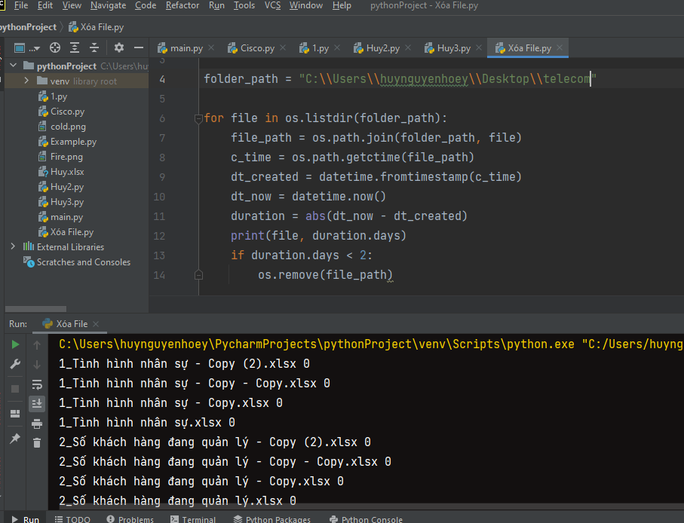

**Source code:**

|  |
| --- |
| import os  from datetime import datetime  folder_path = "C:\\Users\\huynguyenhoey\\Desktop\\telecom"  for file in os.listdir(folder_path):  file_path = os.path.join(folder_path, file)  c_time = os.path.getctime(file_path)  dt_created = datetime.fromtimestamp(c_time)  dt_now = datetime.now()  duration = abs(dt_now - dt_created)  print(file, duration.days)  if duration.days < 2:  os.remove(file_path) |

**Step 4:** Doing the same steps to create enough values ​​in each table which is the comparison with the character numbers has already been noted in step 1.

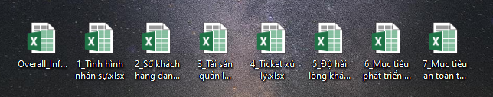

**Step 5:** Importing each database into Power BI fields to compare.

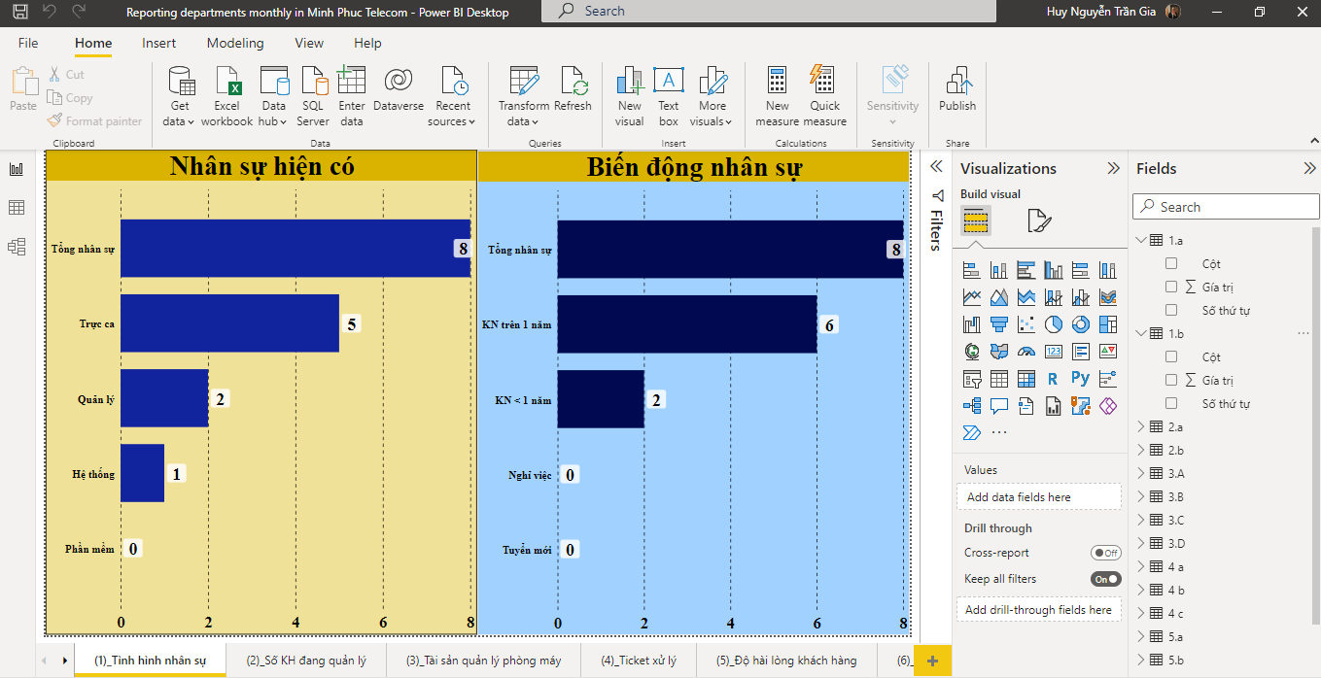

**Step 6:** Finding suitable charts and illustrating valuable information of the reporting departments monthly in Minh Phuc Telecom.

### Results of reporting departments monthly

1. **Chart: Tình hình nhân sự**

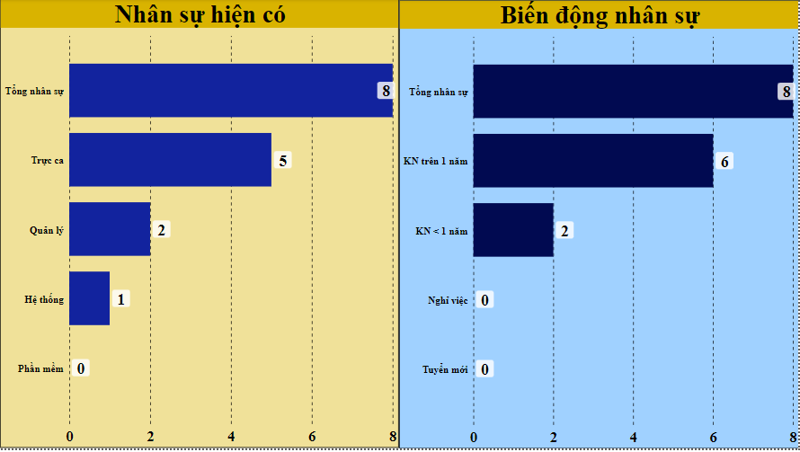

1. **Chart: Số khách hàng đang quản lý**

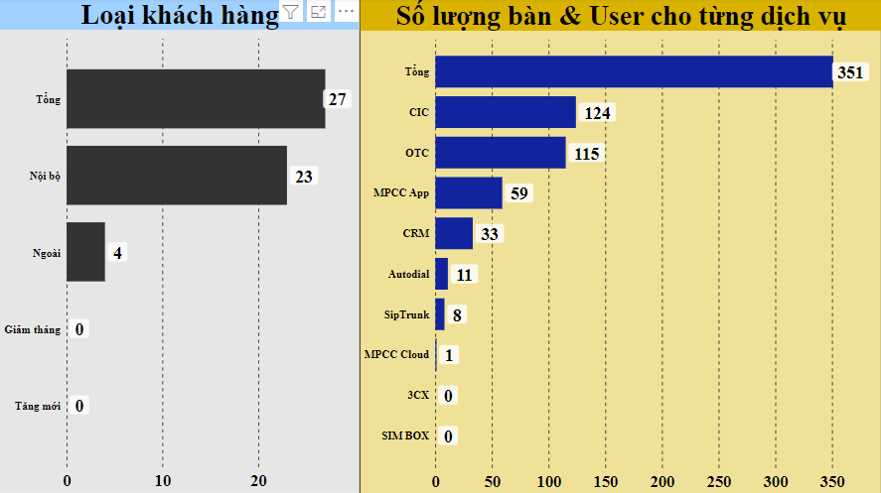

1. **Chart: Tài sản quản lý phòng máy**

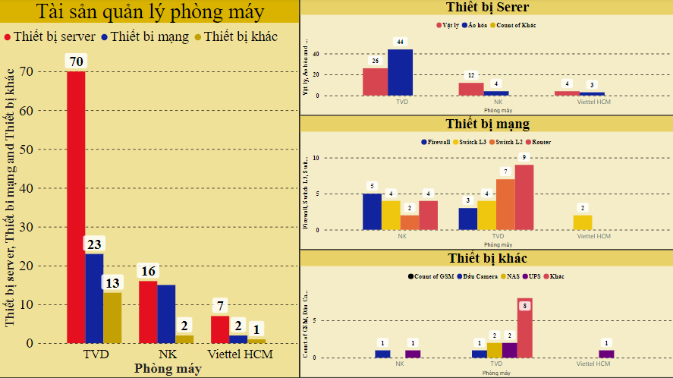

1. **Chart: Ticket xử lý**

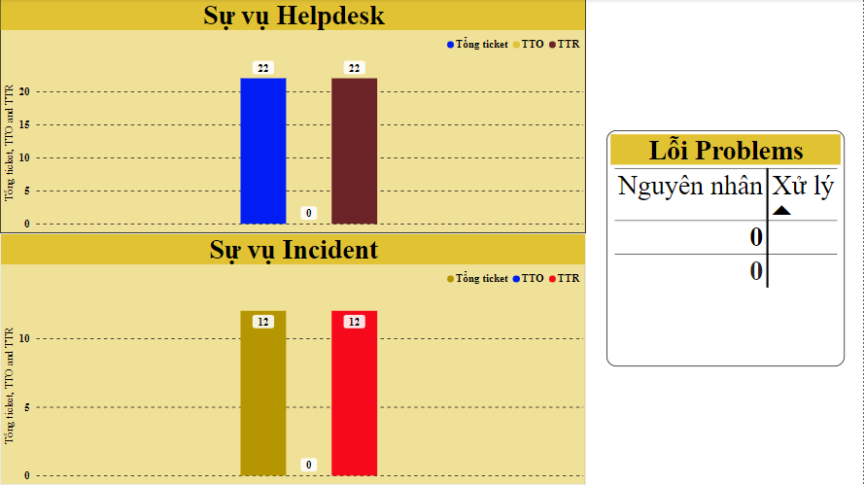

1. **Chart: Độ hài lòng khách hàng**

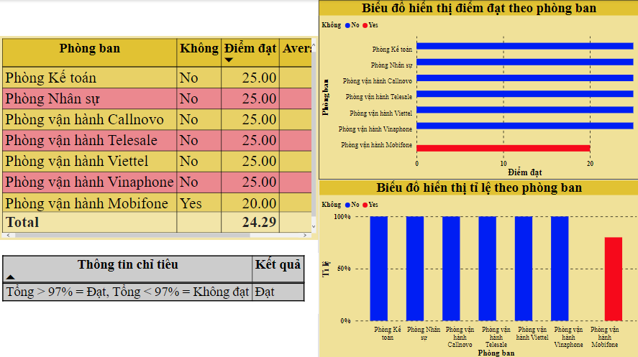

1. **Chart: Mục tiêu phát triên hệ thống**

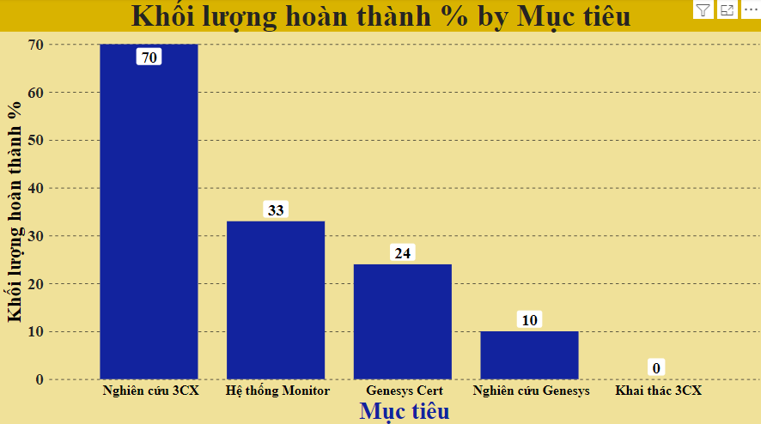

1. **Chart: Mục tiêu an toàn thông tin**

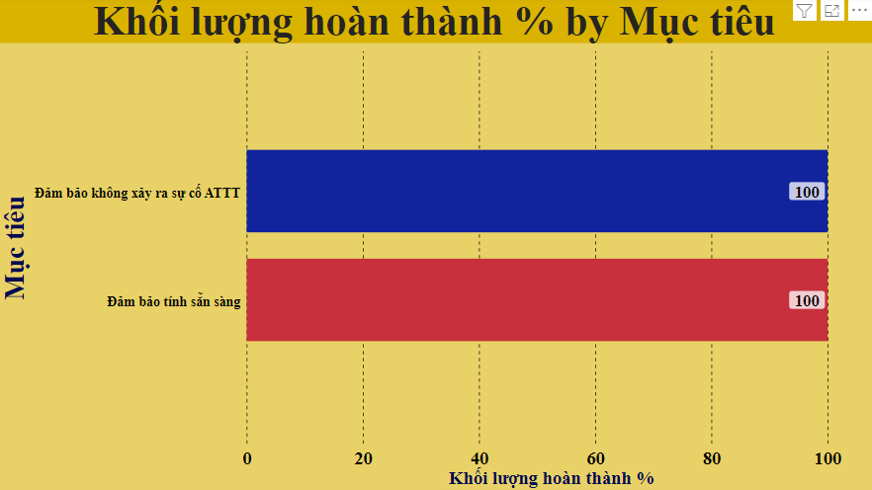

1. **Project 2: Reporting the Interface status of Switch and Bandwidth Information by using Prometheus and Grafana.**
2. **Introduction:**
3. **What is Prometheus?**

- Prometheus is an open-source systems monitoring and alerting toolkit originally built at SoundCloud.

- It records real-time metrics in a time series database (allowing for high dimensionality) built using a HTTP pull model, with flexible queries and real-time alerting.

- Prometheus scrapes metrics from instrumented jobs, either directly or via an intermediary push gateway for short-lived jobs. It stores all scraped samples locally and runs rules over this data to either aggregate and record new time series from existing data or generate alerts.



1. **Architecture**

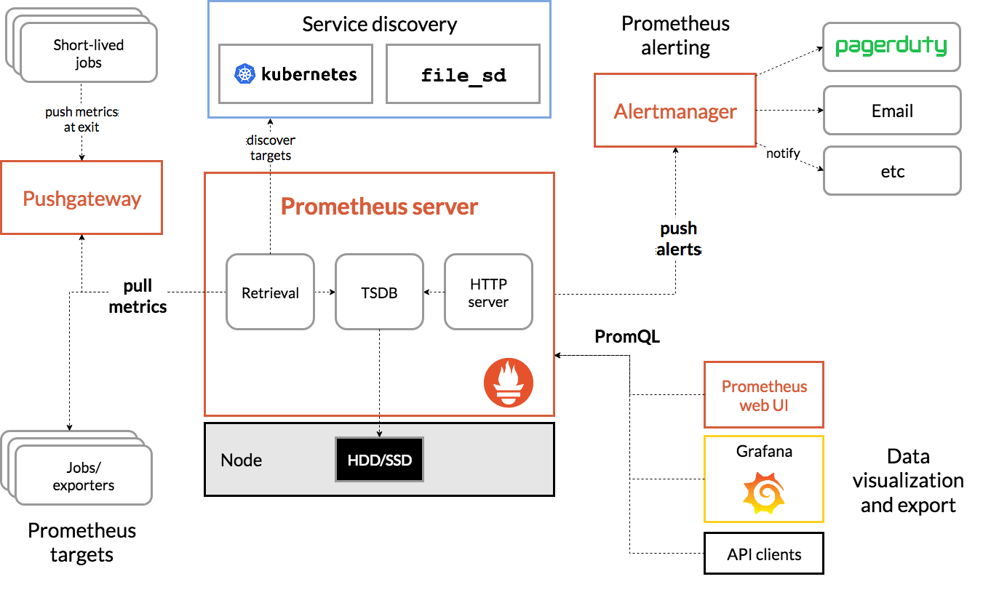

(Background of Prometheus)

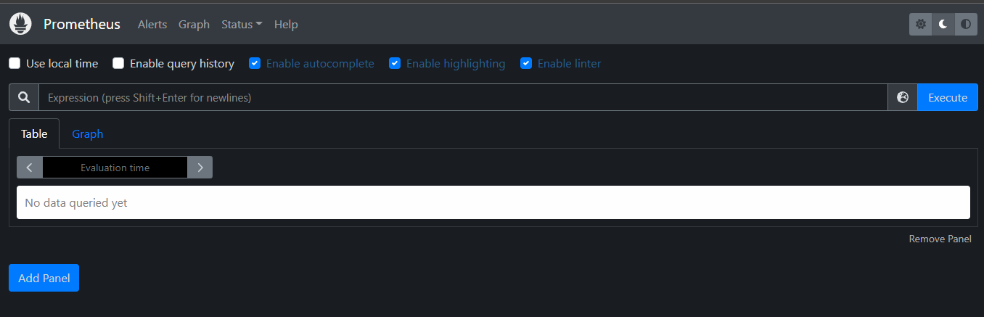

1. **What is Grafana?**

- Grafana is an open-source observability platform for visualizing metrics, logs, and traces collected from your applications. It’s a cloud-native solution for quickly assembling data dashboards that let you inspect and analyze your stack.

- Grafana connects to a variety of data sources such as Prometheus, InfluxDB, ElasticSearch, and traditional relational database engines. Complex dashboards are created by using these sources to select relevant fields from your data. Dashboards can incorporate a varied range of visualization components such as graphs, heat maps, and histograms.

(Background of Grafana)

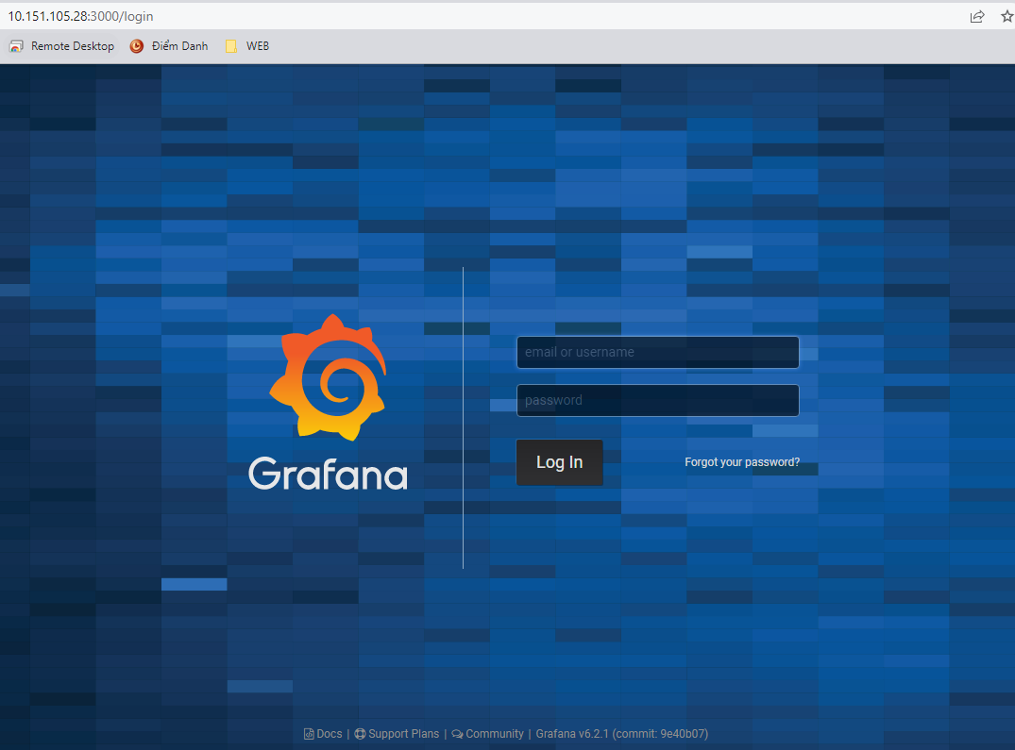

1. **Overview of project:**

The main task in this project is to show clearly information details of Switch and Bandwidth status in the Grafana dashboard by using Prometheus.

Unfortunately, account name, password and Id Address information relating to the security of Minh Phuc Telecom can not be revealed publicly. Therefore, these forms of details that I was provided individually to accomplish this mentioned project.

The project including Grafana, Prometheus and SNMP Exporter.

1. **Achievement:**

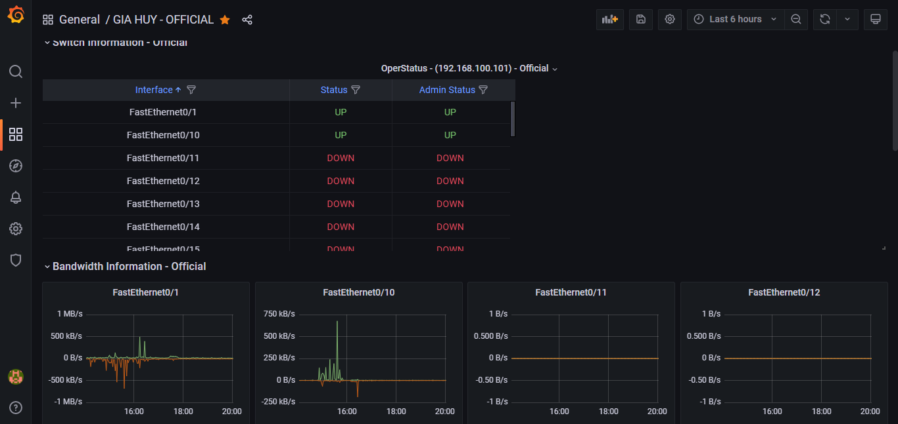

(Overall background of Grafana project dashboard)

1. **The Process to perform the project**

**“Switch Information – Official” Panel**

**Step 1:** Using code information of AdminStatus from SNMP Exporter and using Prometheus to convert values, which is suitable with Grafana dashboard. Afterwards, we can see the final value “1” in the end, which mean the Switch is “UP” and “2” is “DOWN”.

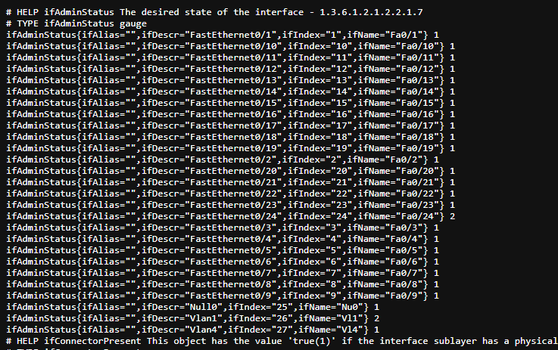

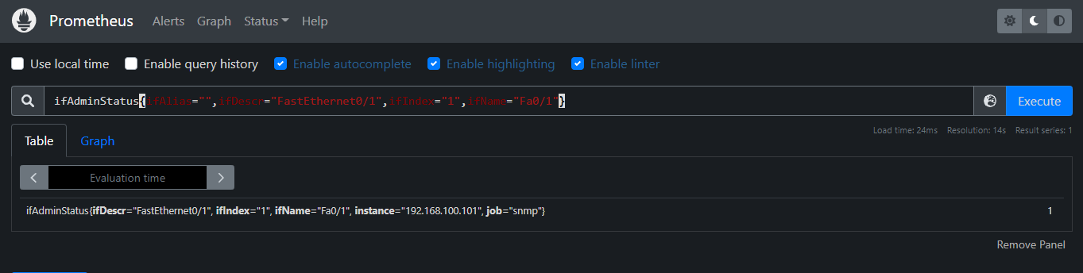

**UP**

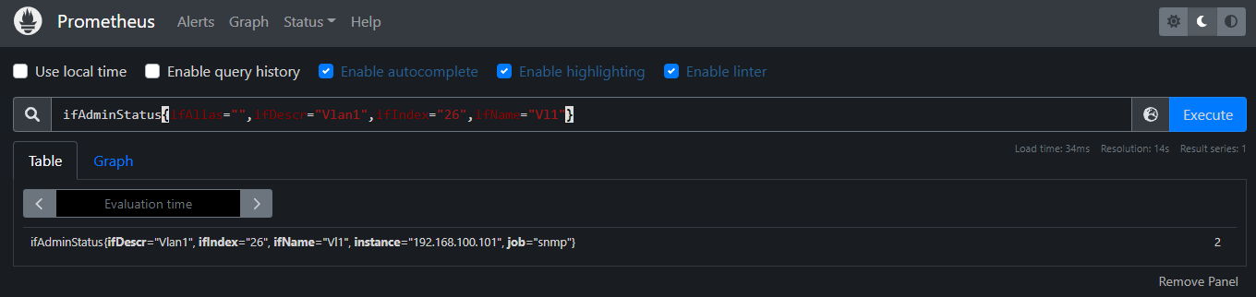

**DOWN**

Definitions of valuable information which is important and necessary.

Device

Interface

Title



**Step 2:** Importing matrics browser into Query of Grafana. Particularly, understanding and searching how to use reasonable codes, then edit options *, which is suitable with the **Table** has chosen.

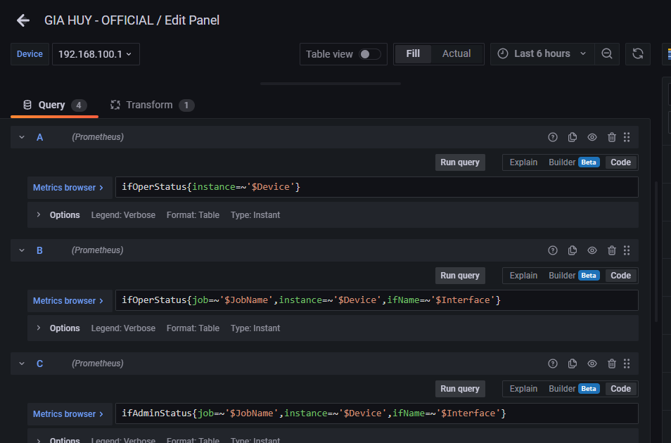

**\***

**\***

**\***

**Step 3:** Choosing the Table, rename and edit value mappings on the right side of the Grafana Dashboard.

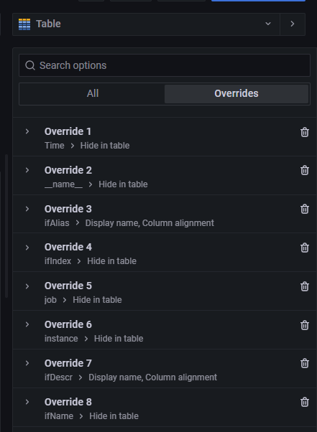 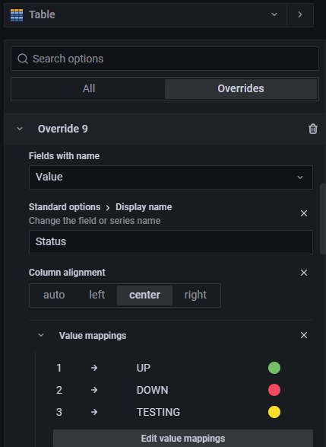

**Step 4:** Showing the result on the main dashboard.

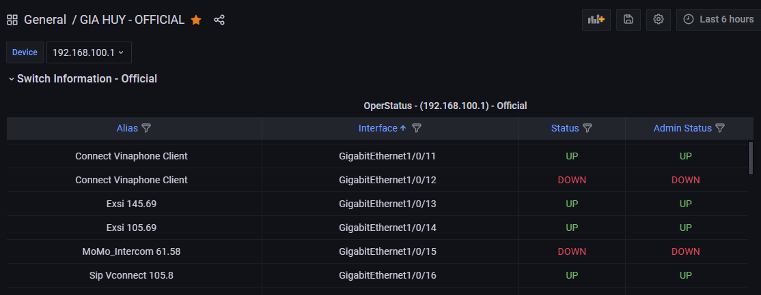

Choose other devices to check, if it shows values unequivocally, it is a complete success.

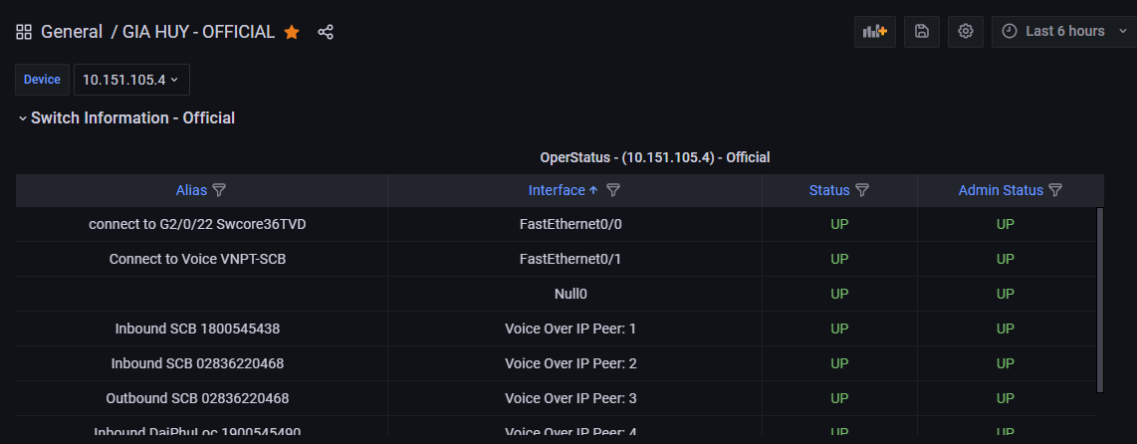

**“Bandwidth Information – Official” Panel**

**Step 1:** Similar to “Switch Information – Official” Panel.

**Step 2:** Adding “irate” into Metrics browsers of Input and Output to show the rate information clearly of each device in the graph (Old).

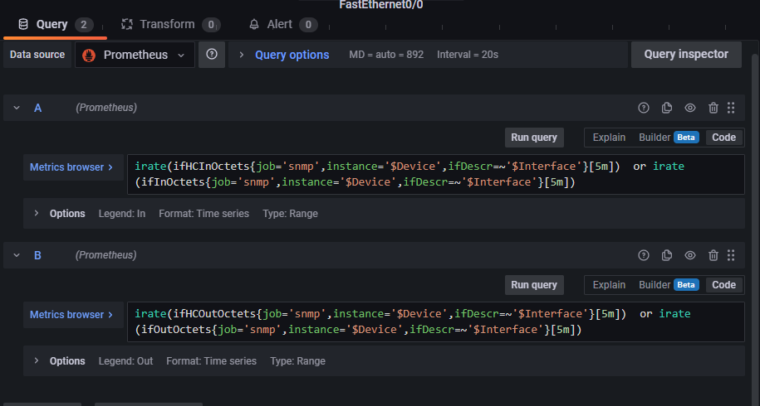

**Step 3:** Editing value mappings to display in a graph (Old) by the options on the right side of the dashboard.

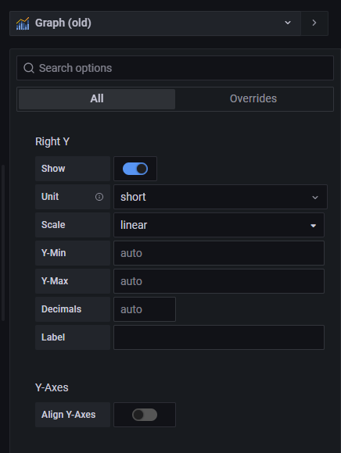 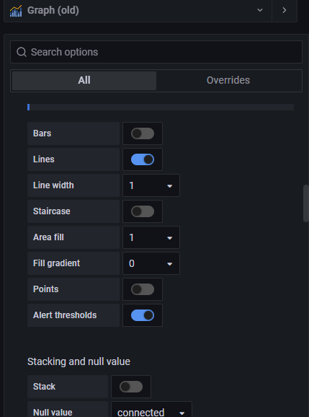

**Step 4:** Showing the result on the main dashboard.

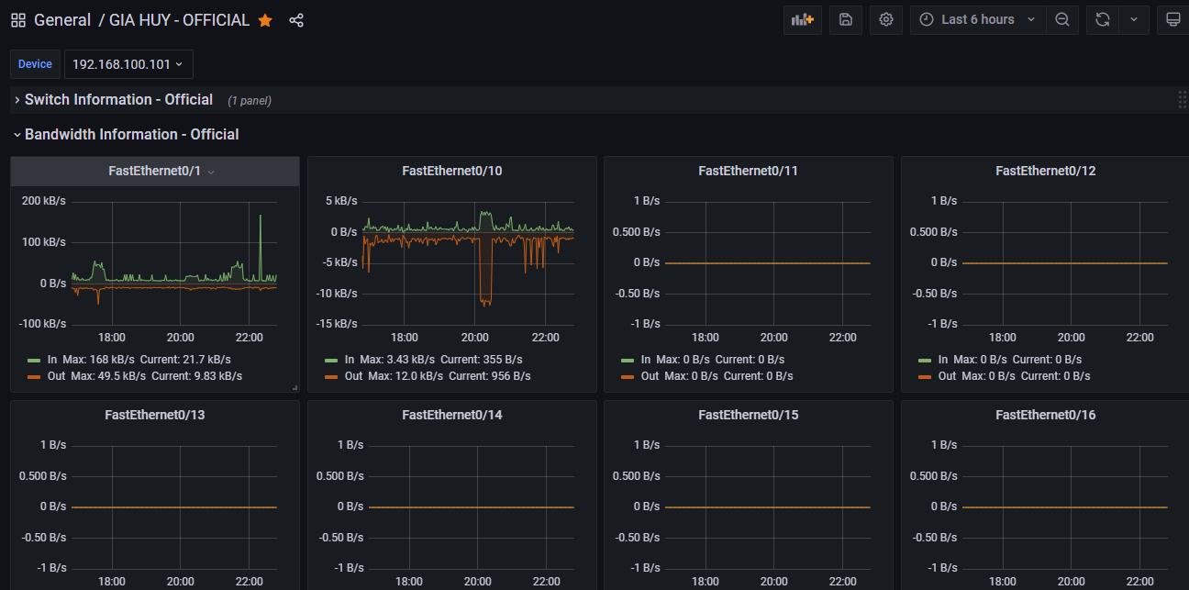

Choose other devices to check, if it shows values unequivocally, it is a complete success.

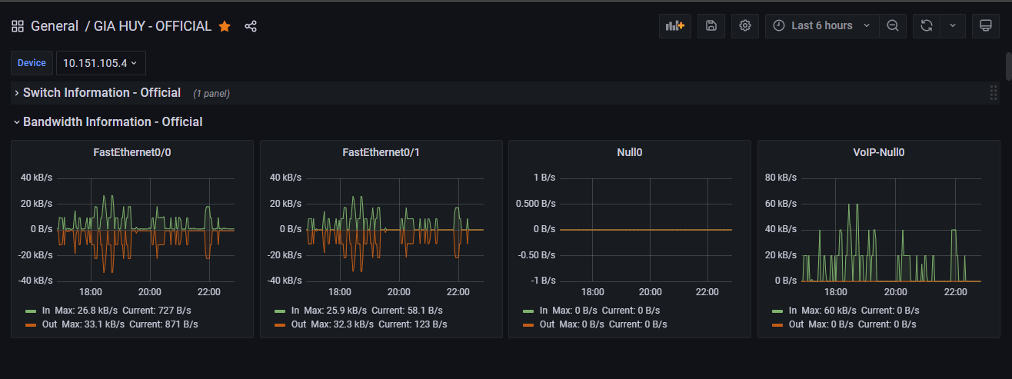

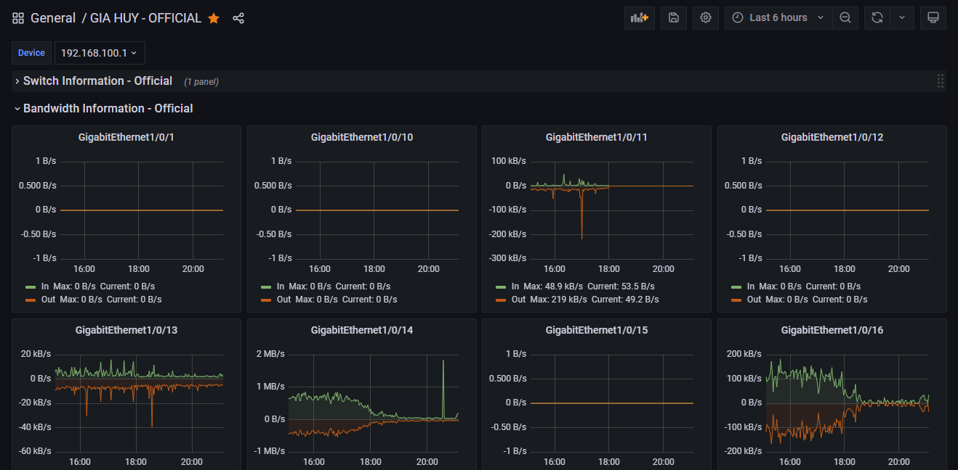

Finally, this is the background result of reporting the Interface status of Switch and Bandwidth Information by using Prometheus and Grafana.

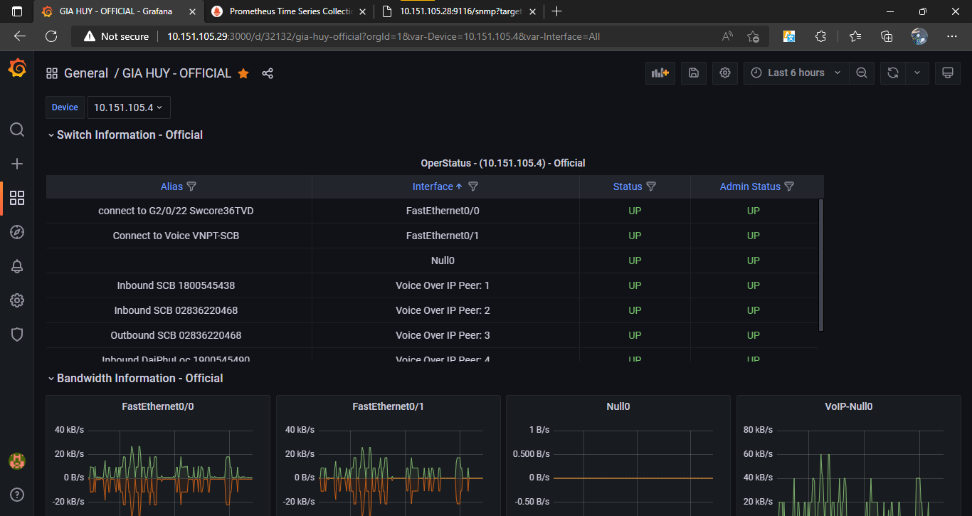

**REFERENCES**

1. <https://www.howtoexcel.org/the-complete-guide-to-power-query/>
2. [SNMP Exporter for Network Equipement — Performance Monitoring with Prometheus and Grafana 1.4.0 documentation (performance-monitoring-with-prometheus.readthedocs.io)](https://performance-monitoring-with-prometheus.readthedocs.io/en/latest/switch.html)
3. <https://grafana.com/grafana/dashboards/>

Chapter 4: Comments and Experiance after 3-month internship

## 1. Comments on internship program

|  |  |
| --- | --- |
| Strength | Weakness |
| * Python and Power BI (Data Analysis) * Prometheus and Grafana (Show status of devices and management) | None |

## 2. Experience after internship program

* Managing project information and understanding how to process, import, export, delete data, etc by Python and visualising several data sources with charts by Power BI.
* Understanding how to work and manage the status of devices in different departments on the Grafana dashboard by using Prometheus. Particularly, learning and understanding how the telecom company successfully operates the management system of devices